Introduction to Global Warming

This graph shows the increases in global average temperature during the last century.

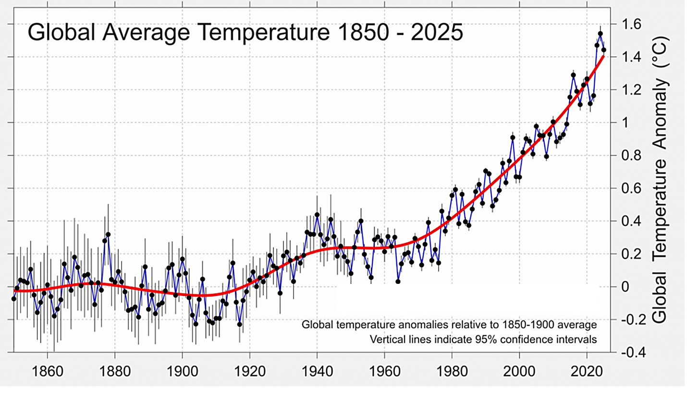

1a. Based on the graph, what is global warming?

1b. Last winter, two weeks were unusually cold. Your friend said that this proved that there really isn’t any global warming. Do you agree ___ or disagree ___?

1c. Explain why.

Several trends were correlated with the increase in global temperatures. For example, the concentration of CO₂ in the earth’s atmosphere increased during the last century. CO₂ levels are now higher than the maximum level during the previous 800,000 years.

2. What do you think was the main cause of the increase during the last century in CO₂ levels in the atmosphere?

3a. Correlated trends do not necessarily imply that one variable has caused the other variable. During the last century, men’s average height and global temperatures both increased. Do these correlated trends mean that the increase in men’s height caused the increase in global temperature? yes ___ no ___

3b. Explain why or why not.

The increase in global temperatures was correlated with an increase in levels of CO₂ in the atmosphere. However, correlation does not prove causation. Scientists have used several types of evidence to test the causal hypothesis that the increase in CO₂ in the atmosphere caused the increase in global temperatures.

First, scientists tested whether there is a mechanism that could explain how more CO₂ in the atmosphere could cause global warming.

4a. Laboratory experiments showed that, when CO₂ molecules absorb infrared radiation, then these CO₂ molecules emit infrared radiation in all directions. Read the labels in the figure below and use the results of the laboratory experiments to complete label c.
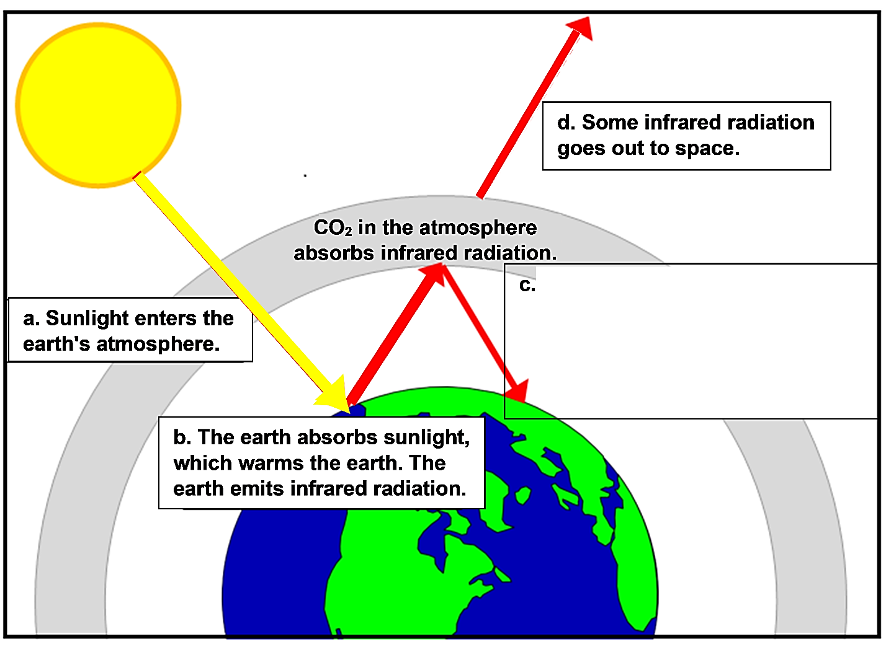

4b. When the amount of CO₂ in the earth’s atmosphere increases:
- the amount of infrared radiation that goes back to earth decreases ___ increases ___;
- the amount of infrared radiation that goes out to space decreases ___ increases ___.

4c. Explain how more CO₂ in the earth’s atmosphere causes an increase in global temperature.

4d. Why is CO₂ called a greenhouse gas?

A second test of the causal hypothesis evaluates whether it can predict future temperature trends. Nineteenth century scientists predicted global warming, based on their understanding of the effects of CO₂ in the atmosphere. More recent models of the effects of CO₂ and other greenhouse gases have successfully predicted future temperature trends.

5. To test whether increases in CO₂ and other greenhouse gases have been the major cause of global warming, scientists have evaluated whether alternative hypotheses could account for the observed trends in global temperature. To see the results, view the animated graph, “How Global Warming Stacks Up” (https://svs.gsfc.nasa.gov/30615). For each factor in the table below, indicate whether changes in this factor would be expected to result in the observed increase in global temperatures.
Possible Cause of Change in Global Temperature | Could this factor be responsible for the observed increase in global temperature?
Changes in the earth’s orbit | Yes ___ No ___
Changes in the temperature of the sun | Yes ___ No ___
Volcanic eruptions | Yes ___ No ___
Forest replaced with types of land-use that reflect more light | Yes ___ No ___
Changes in ozone in the upper and lower atmosphere | Yes ___ No ___
Aerosol pollution | Yes ___ No ___
Increase in greenhouse gases | Yes ___ No ___

6. Summarize the evidence that supports the hypothesis that increases in CO₂ and other greenhouse gases caused the increase in global temperature during the last century.

You may be wondering, “What’s all the fuss about a small increase in average temperature (only ~1.4°C or ~2.6°F thus far)?” Global warming has already increased the probability and/or severity of heat waves, hurricanes, floods, wildfires, and droughts through various mechanisms in various places. For example, global warming increased the severity of the 2022 European heat wave; during the heat wave, global warming was responsible for an estimated 30,000 heat-related deaths.

As would be expected, scientists predict that continued global warming will result in more serious problems. To avoid the worst effects, it will be crucial to limit global warming and the resulting climate change.

7. Suggest actions that you and other people could take to reduce global warming.

By Dr. Ingrid Waldron, Department of Biology, University of Pennsylvania. © 2026. This Student Handout and Teacher Notes (with instructional suggestions and background information) are available at https://serendipstudio.org/exchange/bioactivities/IntroGlobalWarming.

